Viraj Chetan Desai – 210905019

Lab 7 – Study of Domain Name Server

1. Configure the below topology to setup DNS server. R1 will use R2 as DNS server to make
DNS resolutions.

R1 IP configurations:
Enable
configure terminal
hostname R1
interface e0/0
ip address 10.10.10.1 255.255.255.0
no shut
do wr
end
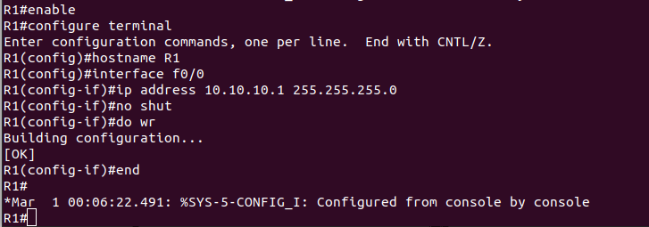

R2 IP and Hostname Configurations:
enable
config t
hostname R2
int e0/0
ip address 10.10.10.2 255.255.255.0
no shut
do wr
end

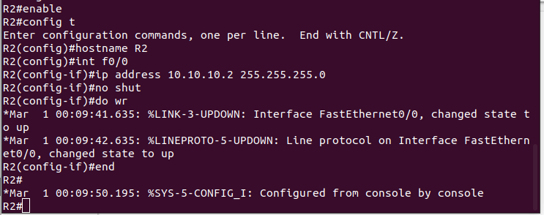

Setting up R2 as DNS Server
config t
ip dns server
ip host loopback.R2.com 2.2.2.2

interface loopback 1
ip address 2.2.2.2 255.255.255.255
end
ping loopback.R2.com
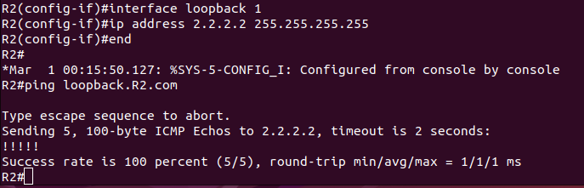
On R1 type :

config terminal
ip domain lookup
ip name-server 10.10.10.2
config t
ip route 0.0.0.0 0.0.0.0 10.10.10.2
end
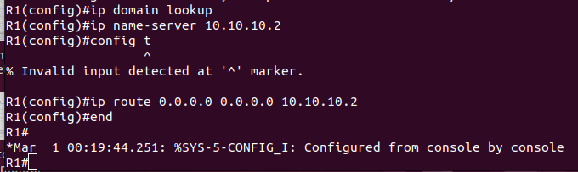

ping loopback.R2.com repeat 3
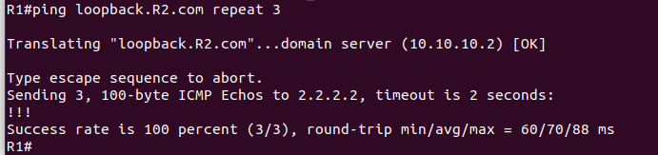

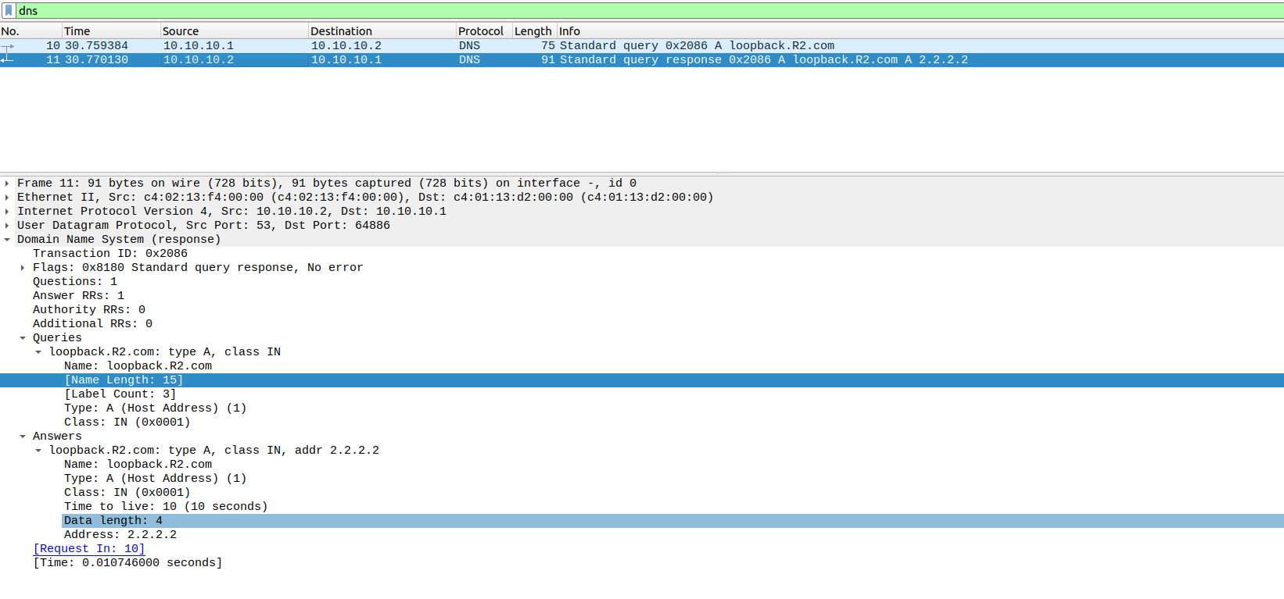

Question -
Suppose you are connecting to www.mycsemit.com to read a page, you are a
user sitting at a client's machine. You can access the www.mycsemit.com web
server. The server machine finds the page you requested and sends it to you.
Build a scenario using GNS3 to demonstrate the interaction of the DNS Server
and DNS Client. Place DNS Server behind two routers.

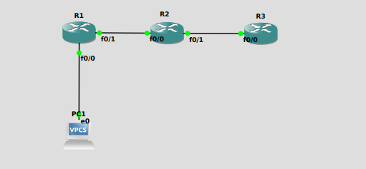

PC1> ip 20.20.20.2/24 20.20.20.3
Checking for duplicate address...
PC1 : 20.20.20.2 255.255.255.0 gateway 20.20.20.3

R1#en
R1#conf t
Enter configuration commands, one per line. End with CNTL/Z.
R1(config)#inter fastethernet0/0
R1(config-if)#ip address 20.20.20.3 255.255.255.0
R1(config-if)#no shut
R1(config-if)#interface faste
*Mar 1 00:06:39.643: %LINK-3-UPDOWN: Interface FastEthernet0/0, changed state to up
*Mar 1 00:06:40.643: %LINEPROTO-5-UPDOWN: Line protocol on Interface FastEthernet0/0, changed state to up
R1(config-if)#interface fastethernet0/1
R1(config-if)#ip address 30.30.30.2 255.255.255.0
R1(config-if)#no shut
R1(config-if)#ip ro
*Mar 1 00:07:02.903: %LINK-3-UPDOWN: Interface FastEthernet0/1, changed state to up
*Mar 1 00:07:03.903: %LINEPROTO-5-UPDOWN: Line protocol on Interface FastEthernet0/1, changed state to up
R1(config-if)#ip route 40.40.40.0 255.255.255.0 30.30.30.3
R1(config)#copy run start

R2#conf t
Enter configuration commands, one per line. End with CNTL/Z.
R2(config)#interface fastethernet0/0
R2(config-if)#ip address 30.30.30.3 255.255.255.0
R2(config-if)#no shutdown
R2(config-if)#interface fastether
*Mar 1 00:04:57.947: %LINK-3-UPDOWN: Interface FastEthernet0/0, changed state to up
*Mar 1 00:04:58.947: %LINEPROTO-5-UPDOWN: Line protocol on Interface FastEthernet0/0, changed state to up
R2(config-if)#interface fastethernet0/1
R2(config-if)#ip address 40.40.40.2 255.255.255.0
R2(config-if)#no shut
R2(config-if)#
*Mar 1 00:05:37.463: %LINK-3-UPDOWN: Interface FastEthernet0/1, changed state to up
*Mar 1 00:05:38.463: %LINEPROTO-5-UPDOWN: Line protocol on Interface FastEthernet0/1, changed state to up
R2(config-if)#ip route 20.20.20.0 255.255.255.0 30.30.30.2
R2(config)#exit
R2#
*Mar 1 00:05:58.503: %SYS-5-CONFIG_I: Configured from console by console
R2#copy run start
Destination filename [startup-config]?
Building configuration...
[OK]

R3#en
R3#conf t
Enter configuration commands, one per line. End with CNTL/Z.
R3(config)#iter fastethernet0/0
^
% Invalid input detected at '^' marker.

R3(config)#inter fastethernet0/0
R3(config-if)#ip address 40.40.40.3 255.255.255.0
R3(config-if)#no shutdown
R3(config-if)#up route
*Mar 1 00:06:12.023: %LINK-3-UPDOWN: Interface FastEthernet0/0, changed state to up
*Mar 1 00:06:13.023: %LINEPROTO-5-UPDOWN: Line protocol on Interface FastEthernet0/0, changed state to up
R3(config-if)#ip route 20.20.20.0 255.255.255.0 40.40.40.2
R3(config)#ip route 20.20.20.0 255.255.255.0 40.40.40.2
R3(config)#ip route 30.30.30.0 255.255.255.0 40.40.40.2
R3(config)#exit
R3#
*Mar 1 00:07:05.479: %SYS-5-CONFIG_I: Configured from console by console
R3#conf t
Enter configuration commands, one per line. End with CNTL/Z.
R3(config)#ip dns server
R3(config)#ip host www.mycsemit.com 40.40.40.3
R3(config)#exit
R3#
*Mar 1 00:08:54.283: %SYS-5-CONFIG_I: Configured from console by console
R3#copy run start
Destination filename [startup-config]?
Building configuration...
[OK]
R3#conf t
Enter configuration commands, one per line. End with CNTL/Z.
R3(config)#inter fastethernet0/0
R3(config-if)#ip route 30.30.30.0 255.255.255.0 40.40.40.2
R3(config)#inter fastethernet0/0
R3(config-if)#ip route 20.20.20.0 255.255.255.0 40.40.40.2
R3(config)#exit
R3#
*Mar 1 00:14:44.991: %SYS-5-CONFIG_I: Configured from console by console
R3#copy run start
Destination filename [startup-config]?
Building configuration...
[OK]
R3#conf t
Enter configuration commands, one per line. End with CNTL/Z.
R3(config)#ip dns server
R3(config)#ip host www.mycsemit.com 40.40.40.3
R3(config)#exit
R3#
*Mar 1 00:17:28.159: %SYS-5-CONFIG_I: Configured from console by console
R3#copy run start
Destination filename [startup-config]?
Building configuration...
[OK]
R3#

PC1> ping 40.40.40.3

40.40.40.3 icmp_seq=1 timeout
40.40.40.3 icmp_seq=2 timeout
84 bytes from 40.40.40.3 icmp_seq=3 ttl=253 time=54.830 ms
84 bytes from 40.40.40.3 icmp_seq=4 ttl=253 time=51.162 ms
84 bytes from 40.40.40.3 icmp_seq=5 ttl=253 time=41.827 ms

PC1> ip dns 40.40.40.3

PC1> ping www.mycsemit.com
www.mycsemit.com resolved to 40.40.40.3

84 bytes from 40.40.40.3 icmp_seq=1 ttl=253 time=50.303 ms
84 bytes from 40.40.40.3 icmp_seq=2 ttl=253 time=41.696 ms
84 bytes from 40.40.40.3 icmp_seq=3 ttl=253 time=41.985 ms
84 bytes from 40.40.40.3 icmp_seq=4 ttl=253 time=42.254 ms
84 bytes from 40.40.40.3 icmp_seq=5 ttl=253 time=50.616 ms

